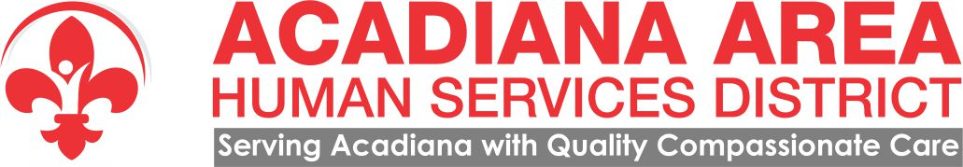

PUBLIC NOTICE

The Board of Directors of Acadiana Area Human Services District
will conduct its monthly meeting on:

The meeting was canceled due to lack of quorum
Monday, October 16, 2017
3:00pm
Ville Platte Behavioral Health Clinic
312 Court Street
Ville Platte, LA 70586

The meeting is open to the public.

